
Year 11 Mathematics Methods
Investigation 3 2021
Part A: Take Home Section
Instructions: This investigation is made up of two sections: Part A and Part B.
Part A is the practice section, which is to be completed at home. All answers must be done neatly in the spaces provided. Written work must be completed in pen.
Part B is the in-class section which will be a different, but related, problem that will be completed under test conditions on the day Part A is due. Part A must be handed in prior to completing Part B.
Time Allocation: 1 Week

Optimisation
Problem 1: Which solar panel has the greatest area?
The area of a glass solar panel needs to be at a maximum to “collect” the greatest amount of sunlight possible. The shape of the flat solar panel is allowed to vary but the metal strip around the edge of the panel (i.e., around the perimeter) is to be kept at a constant value of 8 m to minimise the cost of making the object.
For the shapes provided, determine the area of the various panels and hence identify the shape with the maximum area.

Optimising a Selection of Shapes

- A square glass panel
The metal strip is 8 m. Determine the length of each side and hence the area of the square panel.

- A triangular glass panel with equal side lengths
The metal strip is 8 m. Determine the length of each side and hence calculate the area of the triangular panel using the formula: $Area=\frac{1}{2}ab\sin{C}$
- A hexagonal glass panel with equal side lengths
The metal strip is 8 m.
Draw a labelled diagram to represent the panel. Identify the length of the sides and the sizes of the equal angles.
Use a dissection method and the formula $Area=\frac{1}{2}ab\sin{C}$ to show that the area of the panel is $Area=\frac{3\sqrt{3}}{2}a^{2}$ where $a$ is the length of each side.
Calculate the area of the hexagonal panel.
- A circular glass panel
The metal strip is 8 m.
Determine the radius of the circular panel and hence the area of the panel.

Analysis of the Results

- Rank the four shapes provided in order of increasing area.
- What feature of these shapes seems to be influencing this ranking?
- Suggest a range of possible values for the area of a regular pentagon
with a perimeter of 8 m. Justify your choice of values.
- Calculate the area of the pentagon and relate your answer to the range of values you predicted.

Problem 2: Which raised garden bed can contain the greatest volume of soil?

Raised garden beds come in a variety of shapes and sizes.
Four three-dimensional shapes have been suggested for investigation.
Assuming each of these shapes can be filled with soil, what is the maximum amount of soil each of the shapes can contain?
The dimensions referenced refer to the inner measurements and the thickness of the garden bed can be assumed to be negligible.

For each of the shapes provided:
- There is a given restriction on the relationship between some dimensions.
- Identify the formula for the volume of the shape.
- Use Calculus techniques to determine the dimensions that maximise the volume.
- Use these dimensions to calculate the maximum volume.

Optimising a Selection of Shapes
- The garden bed is a rectangular prism
The formula for the volume of a rectangular prism is: $Volume=wlh$.
- Given $4h+l=5$ metres and the height ($h$) is half of the width ($w$),
state the formula for volume in terms of $h$ only.
- Determine , the derivative of the expression for volume.
- Let $=0$ and solve for $h$.
[Note: Volume has a maximum value when the derivative is zero.]

- Determine the other dimensions of the garden bed.
[Note: $4h+l=5$ metres and the height ($h$) is half of the width.]
- Substitute these values for $h$, $l$ and $w$ back into the formula for volume and hence determine the maximum volume of soil that can be contained in this garden bed in the shape of a rectangular prism.

- 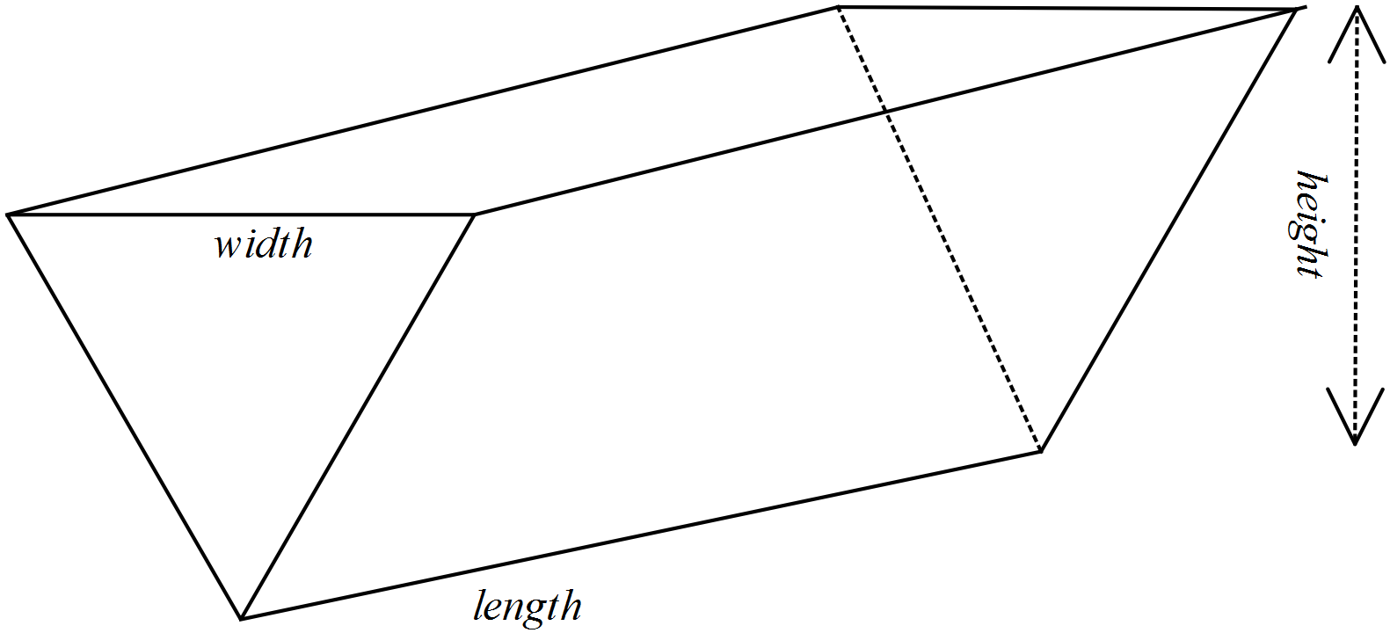The garden bed is a triangular prism
The formula for the volume of this triangular prism is $Volume=0.5wlh$
- Given the length plus width is 5 metres ($w+l=5$) and the height ($h$) is a quarter of the width, state the formula for volume in terms of $w$ only.
- Determine , the derivative of the expression for volume.
- Let = 0 and solve for $w$.
- Determine the other dimensions of the garden bed.
[Note: $w+l=5$ metres and the height ($h$) is a quarter of the width]
- Substitute these values for $h$, $l$and $w$back into the formula for volume and hence determine the maximum volume of soil that can be contained in this garden bed in the shape of a triangular prism.
- The garden bed is a cylinder

- The relationship between the height and the radius of a cylindrical garden bed is $r+4h=5$ metres. Show that the rule for calculating the volume of the garden bed is:
$Volume=\frac{π}{4}\left(5r^{2}-r^{3}\right)$
- Use Calculus techniques to show that the volume is a maximum when the radius is $\frac{10}{3}$ metres.
- Determine the height of the garden bed when the volume is maximised.
- Determine the maximum volume of this cylindrical garden bed.
- The garden bed is a hexagonal prism
The surface of the garden bed is in the shape of a regular hexagon.
The volume of the prism is given by $Volume=Area of Base×h$.
- Use the formula for area from Problem 1 (c.) plus the restriction that $4h+a=5$ metres, where $a$ is the length of each side of the hexagon, to generate a formula for volume in terms of $a$ only.
- Use Calculus techniques to show that a maximum volume of 12.028 $m^{3}$ occurs when
$a=3.3$ metres.
- Calculate the height of the garden bed when the volume is maximised.

Examining your results

Enter your results in a table as follows:

Shape | Restriction | Dimensions for maximum volume | Maximum volume
Rectangular prism
Triangular prism
Cylinder
Hexagonal prism

Comment on your results, considering the following questions.

- Can you conclude that a particular shape will give a maximum volume?
Explain your decision.
- Are any of the measures (volume or dimensions) the same for two or more shapes?
- Would you expect the length to equal the width in the rectangular prism given this situation? Explain your decision.
- What other methods (other than Calculus techniques) could be used to determine the maximum volume of these 3-dimensional shapes?
What are the advantages of using calculus techniques?


Year 11 Mathematics Methods
Investigation 3 2021
Part B: In Class Validation

Instructions: Part B is the in-class validation to be completed under test conditions.
The practice section must be handed in prior to the start of the test. Calculators are permitted
Time Allocation: 60 minutes Total Marks:50 marks

Section 1: Optimising a Selection of Shapes

When travelling by air, some destinations specify luggage limitations in linear measurements rather than weight. This is defined as:
linear measurement = width + height + length.
For one airline the maximum linear measurement is 316 cm for any one piece of luggage.
All the shapes considered in Part A have the maximum linear measurement and are to be investigated for their maximum volume.

Question 1: Luggage is a rectangular prism [12 marks]
The length ($l$) of this item is twice the width ($w$) of the item.

- State the rule to calculate the volume ($V$) of the item. [1]
- Show how you can determine that for the height ($h$), $h=316-3w$ [2]
- Write the rule to calculate the volume in terms of $w$ only. [1]
- Determine [2]
- For what value of $w$ is the volume a maximum? (Use calculus) [2]
- Determine the maximum volume. [2]
- When the volume is a maximum, [2]
- what is the length?
- what is the height?

Question 2: Luggage is a triangular prism [7 marks]

The length ($l$) of this item is twice the width ($w$) of the item.
- Given $V=316w^{2}-3w^{3}$, the rule to calculate the volume ($V$) of the item,
determine . [2]

- Use the expression for identified in part (a.) to determine
the value of $w$ for which the volume is a maximum. [2]
- Calculate the maximum volume. [1]
- When the volume is a maximum, [2]

- what is the length?
- what is the height? (Use the linear measurement condition)
Question 3: Luggage is a cylinder [9 marks]

The linear measurements of a cylinder are the length, width and height of the rectangular prism that would contain this piece of luggage.

- Show that the volume of the cylinder is given by the rule $V=316πr^{2}-4πr^{3}$ [3]
- Use calculus techniques to show that a maximum volume occurs
when the radius ($r$) is $52\frac{2}{3}$ cm [3]
- Determine [3]
- the maximum volume of the cylinder
- the length, width, and height of the cylinder when the volume is at a maximum.

Question 4: Luggage is a hexagonal prism [11 marks]

The linear measurements of a hexagonal prisms are the length, width and height of the rectangular prism that would contain this piece of luggage.

The base is a regular hexagon
The width and length are equal and they are each double the length of the congruent sides of the hexagon.

- 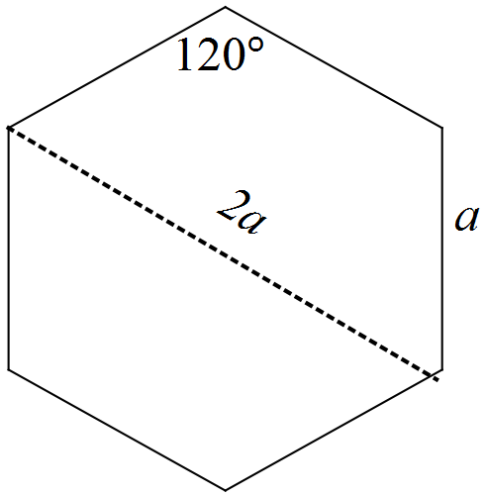The rule for calculating the volume of this hexagonal prism is:
$V=\frac{3\sqrt{3}}{2}(a^{2}h)$
Explain how this rule can be written as:
$V=\frac{3\sqrt{3}}{2}(316a^{2}-4a^{3})$ [3]

- Use calculus techniques to determine the value of $a$ for which this prism has
a maximum volume. [4]
- Determine [4]
- the maximum volume of the hexagonal prism.
- the dimensions of the prism for which the volume is maximised.

Section 2: Analysis

Question 5 [5 marks]

In Section 1, differentiation has been used to identify the dimensions for which
the volume of a 3-dimensional shape can be maximised.

- Describe how technology can be used to identify a maximum value for volume without differentiating the function. [2]
- What does the derivative of the volume function represent? [2]
- Why is the derivative of the volume function equal to zero when the volume reaches its maximum value? [1]

Question 6 [6 marks]

- Enter your results for the items of luggage in the table below. [1]

Shape | Maximum volume  (cm³) | Dimensions for maximum volume  (cm)
 |  | length | width | height
Rectangular prism
Triangular prism
Cylinder
Hexagonal prism

- Rank the items of luggage in order of increasing volume.
Comment on your listing. [1]
- What aspects of the dimensions of luggage items appear to produce shapes with maximum volumes? [2]
- One passenger had an item of luggage that satisfied the rule for maximum linear dimensions but its volume exceeded all of those listed in the table.
Suggest a possible shape and the dimensions for this item of luggage.
Show that its volume is greater than those listed. [2]

This Page Has Been Left Blank Intentionally

